**Overview**

An easy to use Python based GUI editor for CSV files with some ease of use features specific to translating.

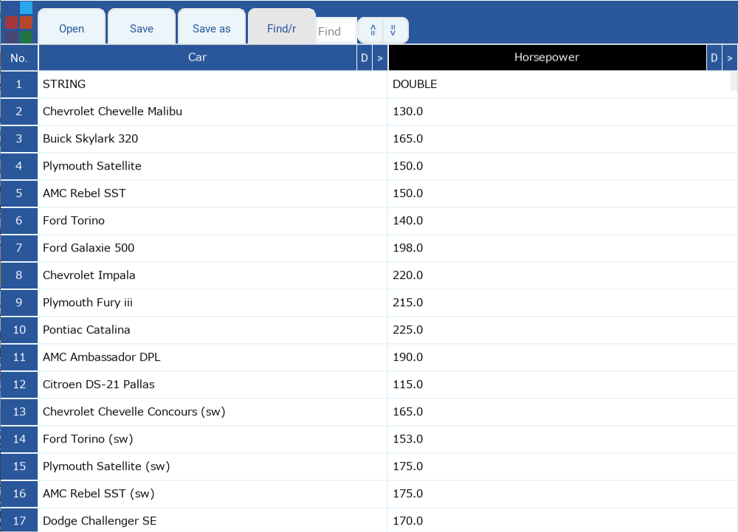

**Install instructions**

Install [Python 3.9.1](https://www.python.org/ftp/python/3.9.1/python-3.9.1-amd64.exe)

Extract contents of [PyCS_V3.1.0.zip](https://mega.nz/file/ygoQQDaA#zcTJUDlU8cXBJLR2wDyBYxn9ohLgRd2FpNQHqtaxmo0) and run PyCSV.py to start editor

Make sure to run PyCSV Requirements Installer.bat before running the script. If you see any error messages, run it again.

**Editor features:-**

**Configuration**

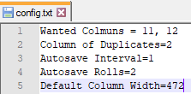

There's a config.txt file alongside the PyCSV script that has 5 lines currently.

**The first** line lets you define what columns will be in the main editor view. Wanted columns should be separated by a comma.

The rest of columns are added to the 'extra details' fields for that row (the extra details feature will be discussed later).

**The second** line of the config let’s you define which wanted column you will perform the duplicates finder function on. (duplicates finder function discussed later)

E.G.

Wanted Columns are 11 and 12

Column of Duplicates is 2

This will make the duplicates finder function work on column 12. The second wanted column.

**The third** line is the auto save interval in minutes. For example, if you want the editor to auto save every minute, set it to 1.

**The fourth** line is the number of autosave backups that will be made before they overwrite themselves in a cycle.

**The fifth** line is the default width for every column when the editor first starts. You can freely change the width of each column in the editor by left clicking and dragging the **>** on right of the columns.

**Navigation**

There are vertical and horizontal scroll bars. You can move the vertical bar with the mouse wheel. The horizontal scroll with the left/right arrows on the keyboard. You can shift up and down between cells by using up/down arrows on the keyboard.

**Find/Replace functions**



When you launch the app you will find the “Find/r” switch. This starts in find mode from app launch. Clicking on Find/r switches it to replace mode. The find/ Replace function works on one column of your choosing. Click the name of the column you want to Search/ Replace on, and it will change colors to black. By default the last column on the right is pre-highlighted/ selected at app launch.

**Extra details**

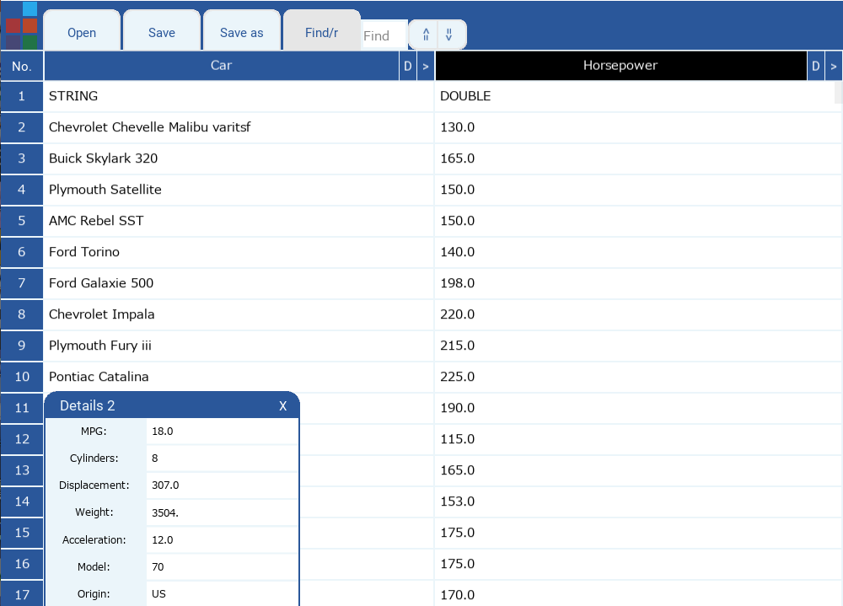

The 'extra details' fields can be accessed by right clicking on a row number. This includes any column data that was in the CSV file and not currently displayed for a row. It’s a floating window so you can move it with your mouse. it’s size changes depending on the data inside. You can also edit any information in the ‘extra details’ fields.

**Duplicates marking and populating**



The duplicates finder function will make row numbers appear in two different colors, grey and silver. Grey rows have the original text, and the silver rows have the duplicates of an original text.

Clicking on a silver row number will jump to the grey row of the original duplicate entry. Clicking on the grey row number jumps you back to the last silver row you clicked.

Editing an original row and hitting the 'insert' key (while the text field is in focus) will apply the changes you made on that row to all it's duplicates.

Hitting CTRL + SHIFT + D will apply all changes made to all rows to all of their duplicates.

**Row highlighting**



Clicking a normal row (that has no duplicates) will change it’s color to black. when you highlight multiple rows, you can jump between them with the 'pageup' and 'pagedown' buttons. This is helpful if you want to revisit lines you had trouble translating, or if you need more context before translating.

**Theme changer**



There's a theme changer in the top left. All Microsoft Office themes are included.

**Go To**



Clicking on the “No.” cell on top left will bring up a goto window. Type the row number and hit the enter key to jump to the specified row. Left clicking the “Go To” button will also work.

**Undo/Redo Bulk Operation**

You can undo/redo any bulk changes like replace/duplicates populating by hitting CTRL + Z and CTRL+SHIFT+Z **while there’s no cell currently selected** (if a cell is selected, you will undo/redo the changes only made to this cell).

**Next to translate**

By hitting F11/F12 you can jump up/down to any lines in the second column that are not translated yet (if a cell is selected, the function will not work, deselect a cell first.)

**Cells resizing**

By CTRL and +/CTRL and -, you will increase/decrease the size and the font size of all the cells.

**Auto save**

The editor will auto save every five minutes by default. You can change the auto save interval time by setting the “Auto save interval” in the config.txt. Intervals are counted in minutes.

**Spellcheck**

While writing in any cell, a suggestion will be listed if the current word you are writing has a misspelling. Hitting enter, or clicking the suggestion, will apply it. The spell check is A.I. based. For now the model is trained to understand all words and SFX used in JSK’s retail games 01 - 23. It understands lewd content correctly as well.